**Advanced Computer Vision**

* We will use all the tools learned, to map out the lane on an image of the road

**Project Steps**

Steps we’ve covered so far:

1. Camera calibration
2. Distortion correction
3. Color/gradient threshold
4. Perspective transform

After doing these steps, you’ll be given two additional steps for the project:

1. Detect lane lines
2. Determine the lane curvature

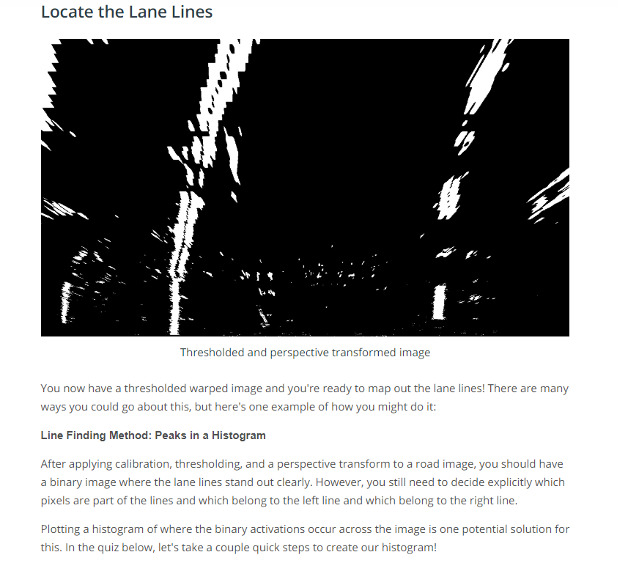

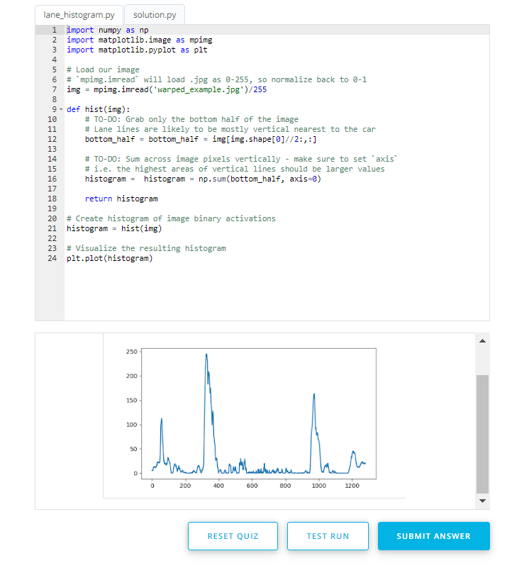

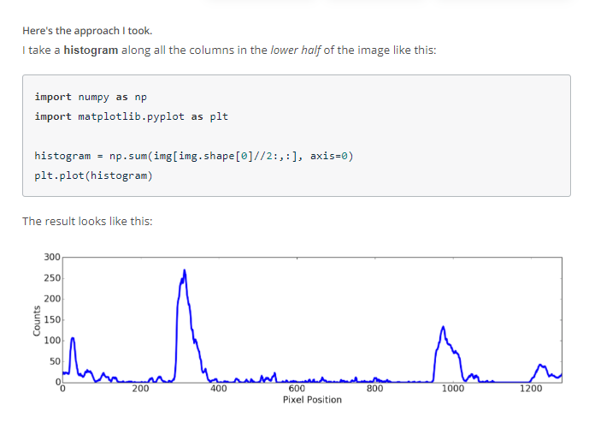

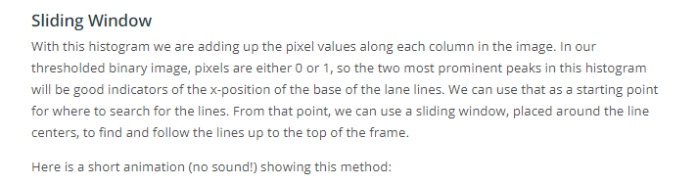

**Video:** <https://www.youtube.com/watch?v=siAMDK8C_x8>

**Finding the Lines: Sliding Window**

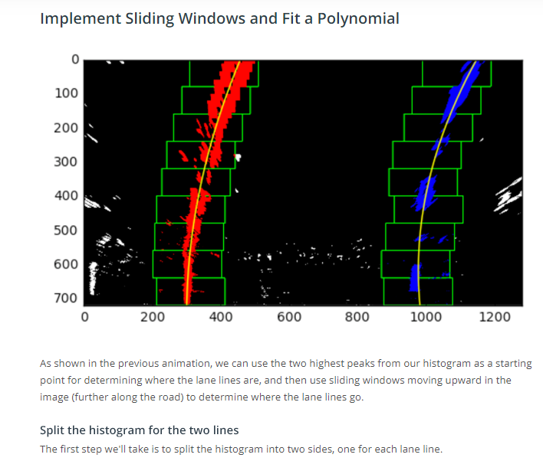

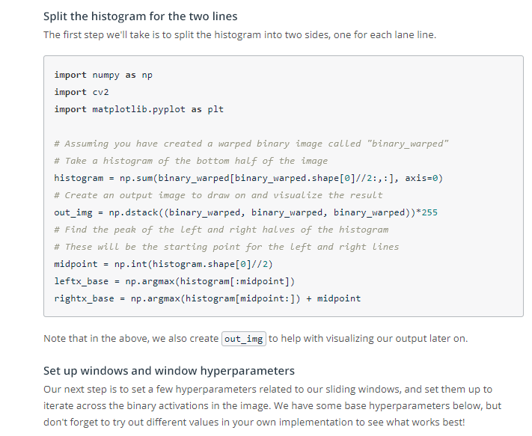

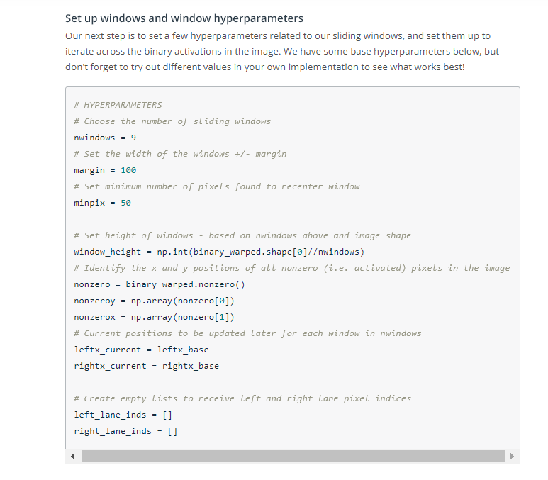

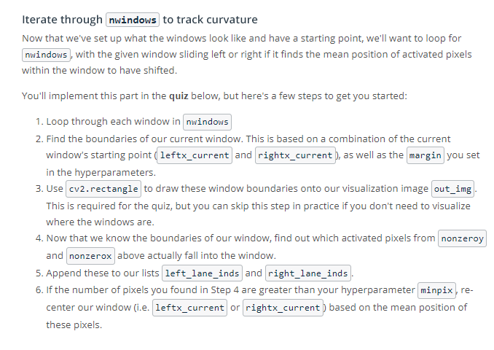

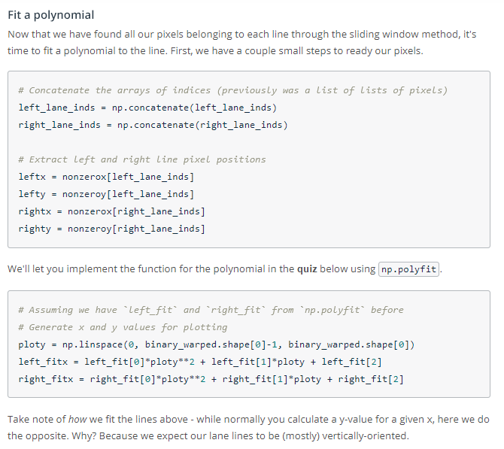

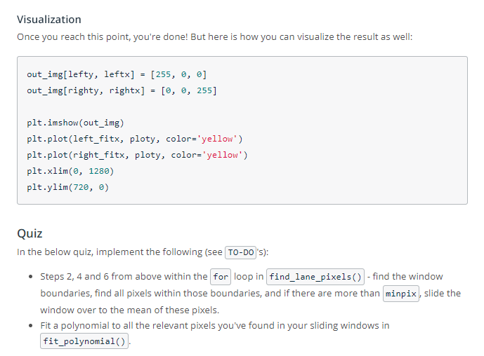



**Finding the Lines: Search from Prior**

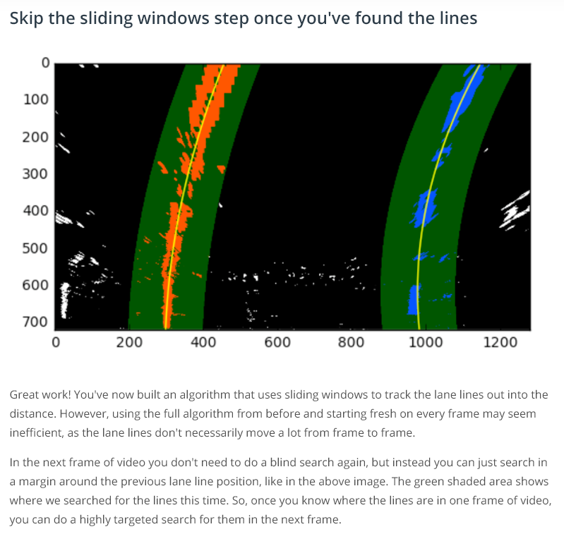

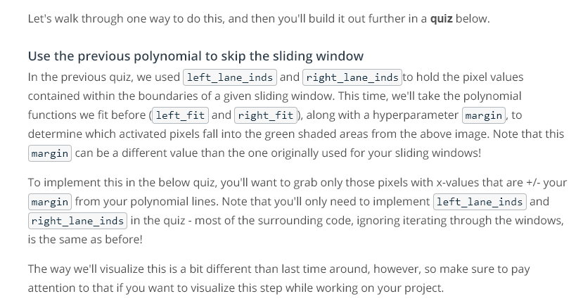

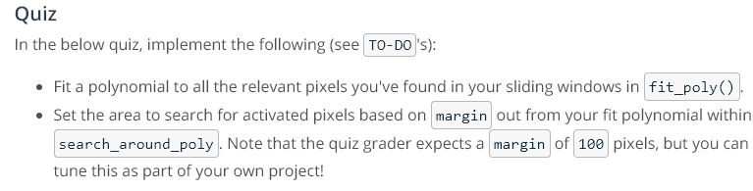



**Measuring Curvature I**

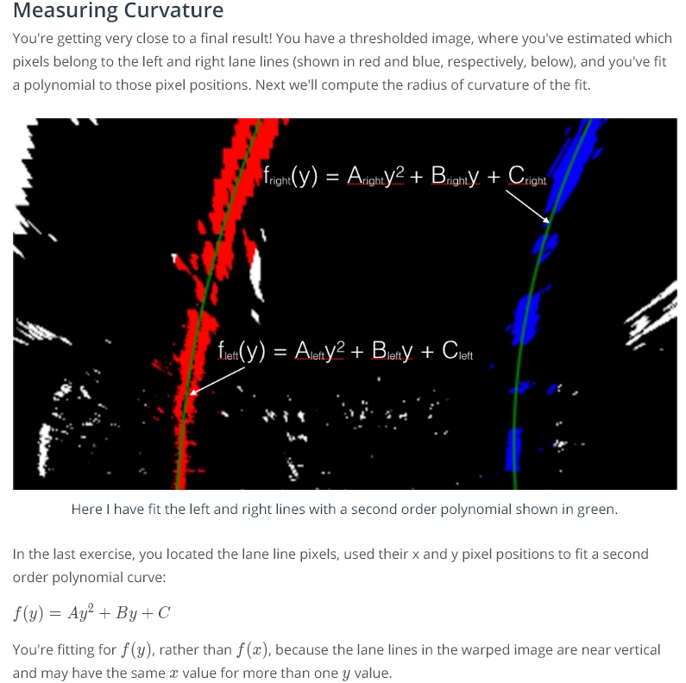

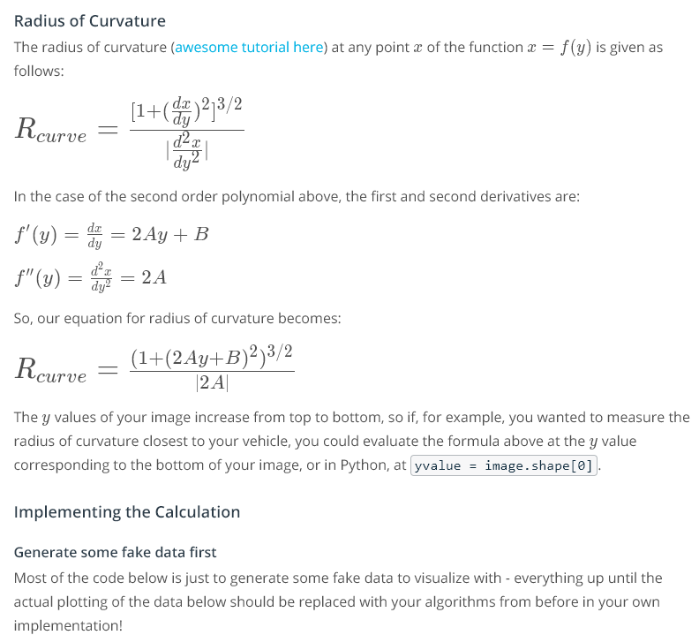

**Radius curvature tutorial:** <https://www.intmath.com/applications-differentiation/8-radius-curvature.php>

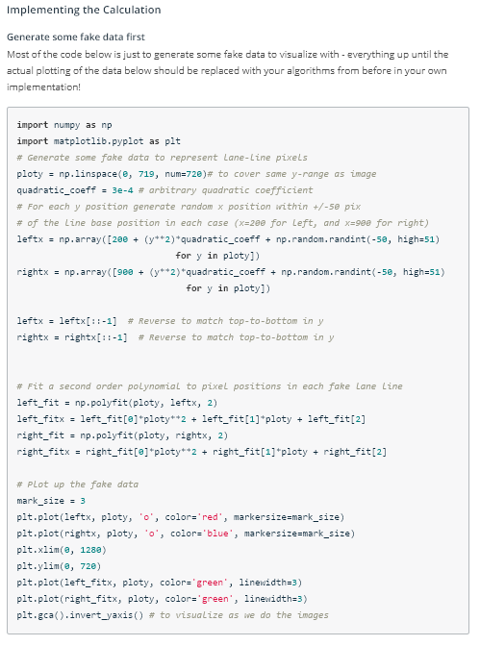

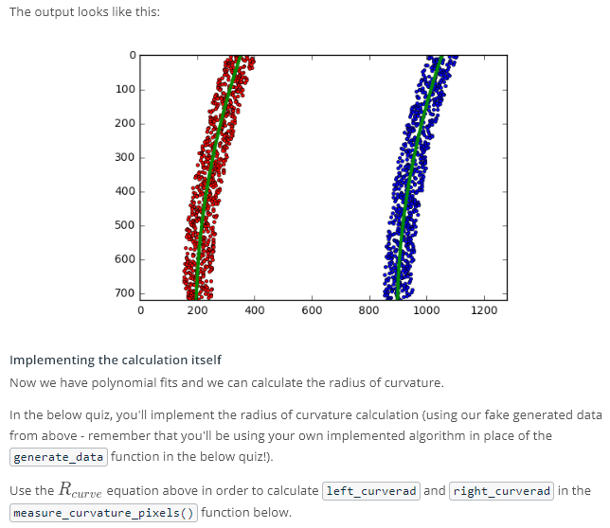



**Measuring Curvature II**

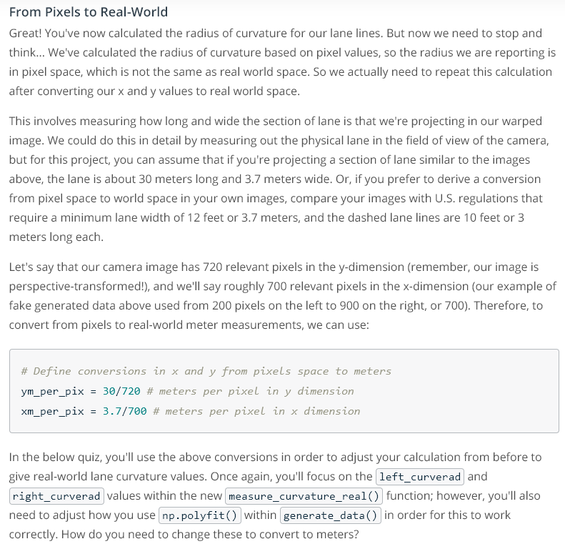



**Bonus Round: Computer Vision [Optional]**

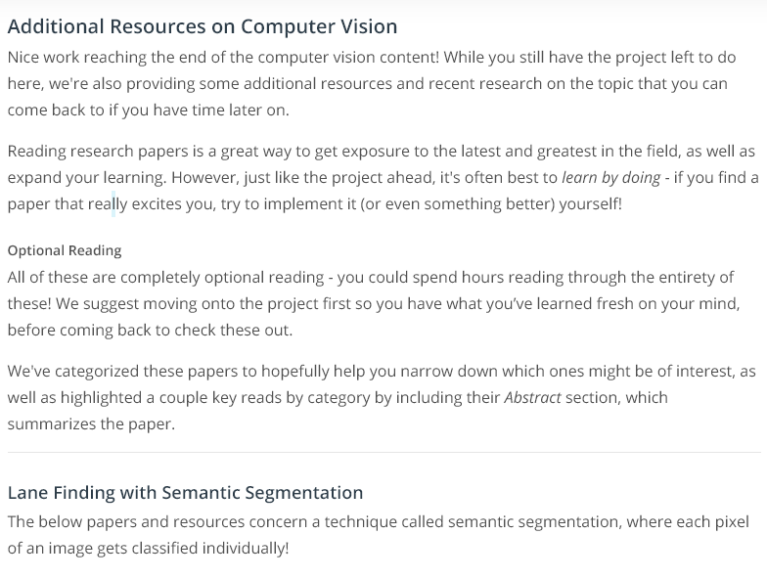

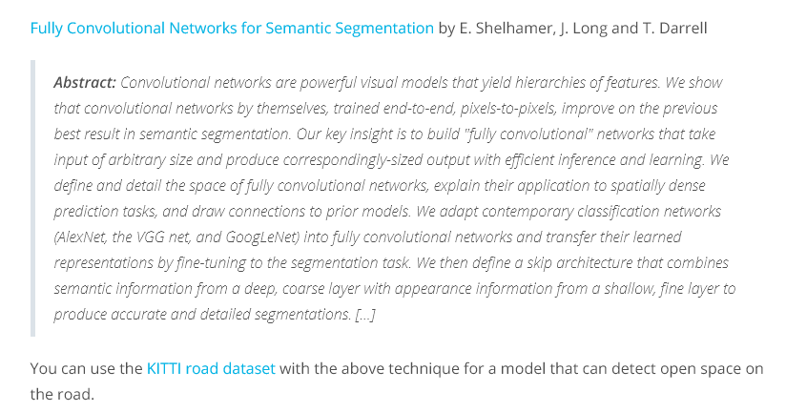

**Links:** <https://arxiv.org/abs/1605.06211>

<http://www.cvlibs.net/datasets/kitti/eval_road.php>

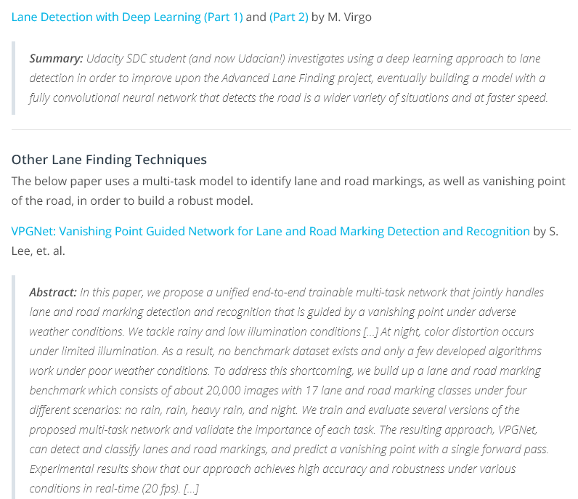

Links:

<https://towardsdatascience.com/lane-detection-with-deep-learning-part-1-9e096f3320b7>

<https://towardsdatascience.com/lane-detection-with-deep-learning-part-2-3ba559b5c5af>

<https://arxiv.org/abs/1710.06288>

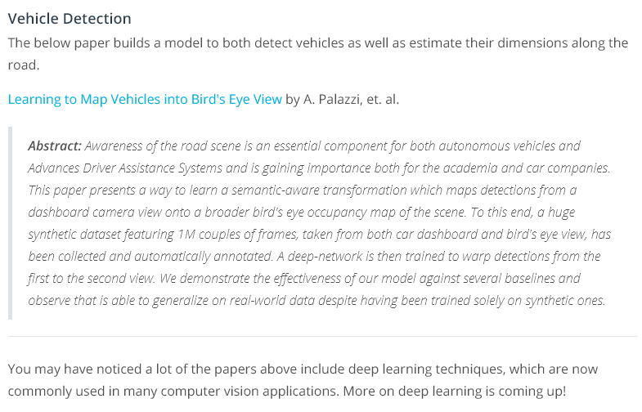

Links:

<https://arxiv.org/abs/1706.08442>